Nutrition, Calories and Canada’s New Food Guide
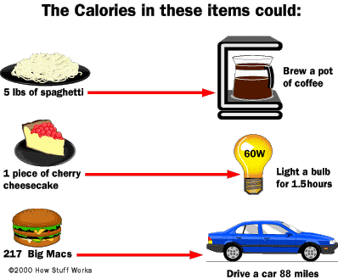
Understanding Calories
Calorie (C) - the amount of energy needed to raise one kilogram of water by one degree Celsius. This is the definition used dealing with food
calorie (c) – the amount of energy needed to raise one gram of water by one degree Celsius

Macronutrients contain a specific amount of energy in each gram of food.
- Carbohydrates = 4 Calories / gram
- Protein = 4 Calories / gram
- Fat = 9 Calories / gram
- Alcohol = 7 Calories / gram

Basil Metabolic Rate
- The minimal caloric requirement needed to sustain life in a resting individual
This is the amount of energy your body would burn if you slept all day.
H = height in meters
Conversions:
Pounds to Kilograms (divide pounds by 2.2)
Inches to cm (multiply inches by 2.54)
W = weight in kilograms
A = age

Men | BMR = (10 × weight in kg) + (6.25 × height in cm) - (5 × age in years) + 5
Women | BMR = (10 × weight in kg) + (6.25 × height in cm) - (5 × age in years) - 161

Calculate your BMR
BMR = (10 × ________ kg) + (6.25 × ______ cm) - (5 × ________age) + 5
=________

Your BMR is higher or will increase if… | Your BMR will be lower or will decrease if…
- You are taller  - You are pregnant  - You have a fever  - You have more muscle mass  - Stress  - Male | - As you get older  - If you are fasting  - Malnutrition  - If you have a decrease in muscle mass
- RMR establishes an important baseline for a weight control program using diet and exercise
- It is possible to gain a general guide to the daily caloric need in sustaining one’s current body weight
- The body cannot store protein or carbohydrates so excess of these macronutrients is stored as fat
Lifestyle | Example | PAL | Calculation
Sedentary or light activity | Office worker getting little or no exercise | 1.53 | BMR x 1.53
Active or moderately active | Construction worker or person running one hour daily | 1.76 | BMR x 1.76
Vigorously active | Agricultural worker (non mechanized) or person swimming two hours daily | 2.25 | BMR x 2.25

Calculate your daily caloric needs by using the chart above
Daily Caloric Needs = BMR x Physical Activity Level (PAL)
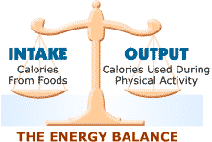
= _________x _________PAL =

Calories and the Energy Equation
Energy equation = Calories in (food and beverage) – Calories out (physical activity, body functions)

Estimated Energy Requirement (EER)
- An EER is defined as the average dietary energy intake that is predicted to maintain energy balance in healthy, normal weight individuals of a defined age, gender, weight, height, and level of physical activity consistent with good health. In children and pregnant and lactating women, the EER includes the needs associated with growth or secretion of milk at rates consistent with good health.
- Estimated Energy Requirement (kcal/day) = Total Energy Expenditure + Energy Deposition
Boys 9 - 18
- EER = 88.5 - (61.9 x age [y]) + PA x { (26.7 x weight [kg]) + (903 x height [m]) } + 25
Girls 9 – 18
- EER = 135.3 - (30.8 x age [y]) + PA x { (10.0 x weight [kg]) + (934 x height [m]) } + 25

Physical Activity Coefficients -(PA values) for use in EER equations
 | Sedentary (PAL 1.0-1.39)  Typical daily living activities (e.g., household tasks, walking to the bus) | Low Active (PAL 1.4-1.59)  Typical daily living activities PLUS 30 - 60 minutes of daily moderate activity (ex. walking at 5-7 km/h) | Active (PAL 1.6-1.89)  Typical daily living activities PLUS At least 60 minutes of daily moderate activity | Very Active (PAL 1.9-2.5)  Typical daily living activities PLUS At least 60 minutes of daily moderate activity PLUS An additional 60 minutes of vigorous activity or 120 minutes of moderate activity
Boys 3 - 18 y | 1.00 | 1.13 | 1.26 | 1.42
Girls 3 - 18 y | 1.00 | 1.16 | 1.31 | 1.56
Men 19 y + | 1.00 | 1.11 | 1.25 | 1.48
Women 19 y + | 1.00 | 1.12 | 1.27 | 1.45
Calculate your EER
EER = 88.5 - (61.9 x _____ [y]) + ____PA x { (26.7 x ______[kg]) + (903 x______ [m]) } + 25
EER = ___________calories
Body Mass Index
- Used to assess the extent to which individuals are balancing the energy equation
- Ratio of a person’s weight in kilograms to the square of his or her height in meters
BMI = Weight (kg)  Height² (m) | BMI = ________ (kg)  ________² (m)  =
- A score of 18.5 to 24.9 is considered normal
- A score of 25.0 to 29.9 is considered overweight
- A score of greater than 30 is considered obese

- In most cases, BMI correlates well with increased risks of disease, particularly cardiovascular, pancreatic, and kidney disease
- However, it does not distinguish between fat and excess muscle
  - E.g. athletes such as wrestlers and football players would record high BMI’s but this may have no relation to their overall health and mortality

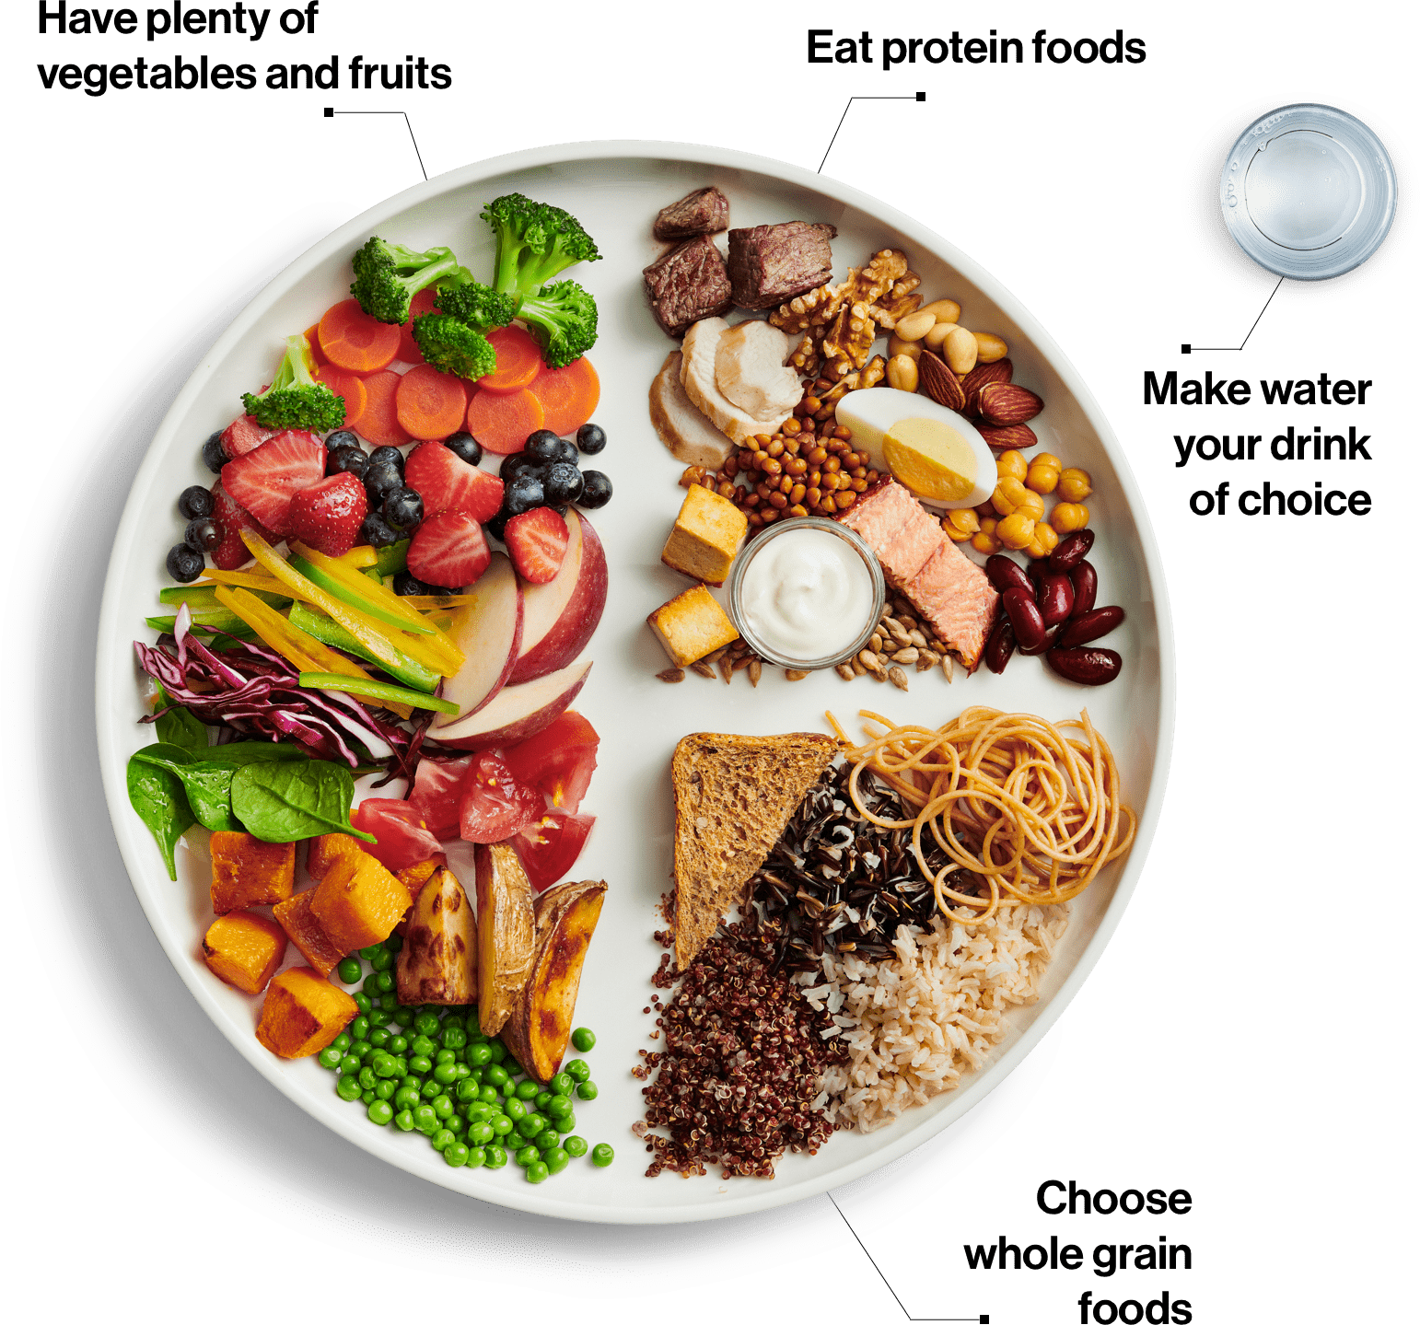
Canada’s New Food Guide
Eat plenty of vegetables and fruits, whole grain foods and protein foods. Choose protein foods that come from plants more often.

Choose foods with healthy fats instead of saturated fat
Limit highly processed foods. If you choose these foods, eat them less often and in small amounts.

Prepare meals and snacks using ingredients that have little to no added sodium, sugars or saturated fat
Choose healthier menu options when eating out
Make water your drink of choice

Replace sugary drinks with water
Use food labels

Be aware that food marketing can influence your choices

Nutrition, Calories and Canada’s New Food Guide
Understanding Calories
________________ - the amount of energy needed to raise one kilogram of water by one degree Celsius. This is the definition used dealing with food
_________________ – the amount of energy needed to raise one gram of water by one degree Celsius

Macronutrients contain a specific amount of energy in each gram of food.
- Carbohydrates = _____ Calories / gram
- Protein =______ Calories / gram
- Fat = ______ Calories / gram
- Alcohol = ______ Calories / gram

Basil Metabolic Rate
- ________________________________________________________________________________________________________________________________________________
This is the amount of energy your body would burn if you slept all day.
H = height in meters
Conversions:
Pounds to Kilograms (divide pounds by 2.2)
Inches to cm (multiply inches by 2.54)
W = weight in kilograms
A = age

Men | BMR = (10 × weight in kg) + (6.25 × height in cm) - (5 × age in years) + 5
Women | BMR = (10 × weight in kg) + (6.25 × height in cm) - (5 × age in years) - 161

Calculate your BMR
BMR = (10 × ________ kg) + (6.25 × ______ cm) - (5 × ________age) + 5
=________
Your BMR is higher or will increase if… | Your BMR will be lower or will decrease if…
- You are pregnant  - You have a fever  - You have more muscle mass  - Male | - If you are fasting  - If you have a decrease in muscle mass
- RMR establishes an important baseline for a weight control program using diet and exercise
- It is possible to gain a general guide to the daily caloric need in sustaining one’s current body weight
- The body cannot store protein or carbohydrates so excess of these macronutrients is stored as fat
Lifestyle | Example | PAL | Calculation
Sedentary or light activity | Office worker getting little or no exercise | 1.53 | BMR x 1.53
Active or moderately active | Construction worker or person running one hour daily | 1.76 | BMR x 1.76
Vigorously active | Agricultural worker (non mechanized) or person swimming two hours daily | 2.25 | BMR x 2.25

Calculate your daily caloric needs by using the chart above
Daily Caloric Needs = BMR x Physical Activity Level (PAL)
= _________x _________PAL =

Calories and the Energy Equation
Energy equation = Calories in (food and beverage) – Calories out (physical activity, body functions)

Estimated Energy Requirement (EER)
- An EER is defined as the average dietary energy intake that is predicted to maintain energy balance in healthy, normal weight individuals of a defined age, gender, weight, height, and level of physical activity consistent with good health. In children and pregnant and lactating women, the EER includes the needs associated with growth or secretion of milk at rates consistent with good health.
- Estimated Energy Requirement (kcal/day) = Total Energy Expenditure + Energy Deposition
Boys 9 - 18
- EER = 88.5 - (61.9 x age [y]) + PA x { (26.7 x weight [kg]) + (903 x height [m]) } + 25
Girls 9 – 18
- EER = 135.3 - (30.8 x age [y]) + PA x { (10.0 x weight [kg]) + (934 x height [m]) } + 25

Physical Activity Coefficients -(PA values) for use in EER equations
 | Sedentary (PAL 1.0-1.39)  Typical daily living activities (e.g., household tasks, walking to the bus) | Low Active (PAL 1.4-1.59)  Typical daily living activities PLUS 30 - 60 minutes of daily moderate activity (ex. walking at 5-7 km/h) | Active (PAL 1.6-1.89)  Typical daily living activities PLUS At least 60 minutes of daily moderate activity | Very Active (PAL 1.9-2.5)  Typical daily living activities PLUS At least 60 minutes of daily moderate activity PLUS An additional 60 minutes of vigorous activity or 120 minutes of moderate activity
Boys 3 - 18 y | 1.00 | 1.13 | 1.26 | 1.42
Girls 3 - 18 y | 1.00 | 1.16 | 1.31 | 1.56
Men 19 y + | 1.00 | 1.11 | 1.25 | 1.48
Women 19 y + | 1.00 | 1.12 | 1.27 | 1.45
Calculate your EER
EER = 88.5 - (61.9 x _____ [y]) + ____PA x { (26.7 x ______[kg]) + (903 x______ [m]) } + 25
EER = ___________calories
Body Mass Index
- Used to assess the extent to which individuals are balancing the energy equation
- Ratio of a person’s weight in kilograms to the square of his or her height in meters
BMI = Weight (kg)  Height² (m) | BMI = ________ (kg)  ________² (m)  =
- A score of 18.5 to 24.9 is considered _____________
- A score of 25.0 to 29.9 is considered _____________
- A score of greater than 30 is considered ____________

- In most cases, BMI correlates well with increased risks of disease, particularly cardiovascular, pancreatic, and kidney disease
- However, it does not distinguish between fat and excess muscle
  - E.g. athletes such as wrestlers and football players would record high BMI’s but this may have no relation to their overall health and mortality

Canada’s New Food Guide
Eat plenty of vegetables and fruits, whole grain foods and protein foods. Choose protein foods that come from plants more often.

Choose foods with healthy fats instead of saturated fat
Limit highly processed foods. If you choose these foods, eat them less often and in small amounts.

Prepare meals and snacks using ingredients that have little to no added sodium, sugars or saturated fat
Choose healthier menu options when eating out
_______________________________

Replace sugary drinks with water
Use food labels

Be aware that food marketing can influence your choices

Questions
- What was you BMR? Show calculations

- Based on your BMR score, do you think that the category that you fall into is accurate? Explain.

- What was your calculated caloric needs based on your BMR and daily activity?

- What was your EER?

- Why do you think that your EER calories and your BMR x PAL is a different number?

- Looking at the picture on the new Canada’s food guide, how does this plate differ from previous food guides? List at least three things.

- Why do you think the food guide says “Be aware that food marketing can influence your choices” ?

- Why would you want to limit highly processed food?

- The new Canada’s food guide has a lot less meat, dairy and grains. Do you think this will influence your current diet?

